Life Management 2.0 (Android Version)

Installation and Maintenance Manual

Authors: Lazaro Fernandez,

Natalia Filippova

**1.** To begin with, you will need a program called ‘Github Desktop’ because you are going to be transferring files that are quite big. Go to https://desktop.github.com and download the latest version (Compatible with macOS and Windows).

Then go to this link:

https://github.com/FIU-SCIS-Senior-Projects/Life-Management-Mobile-App-2.0

Click on the arrow shown below and click on ‘Lazaro-Fernandez’ or ‘Natalia-Filippova’.

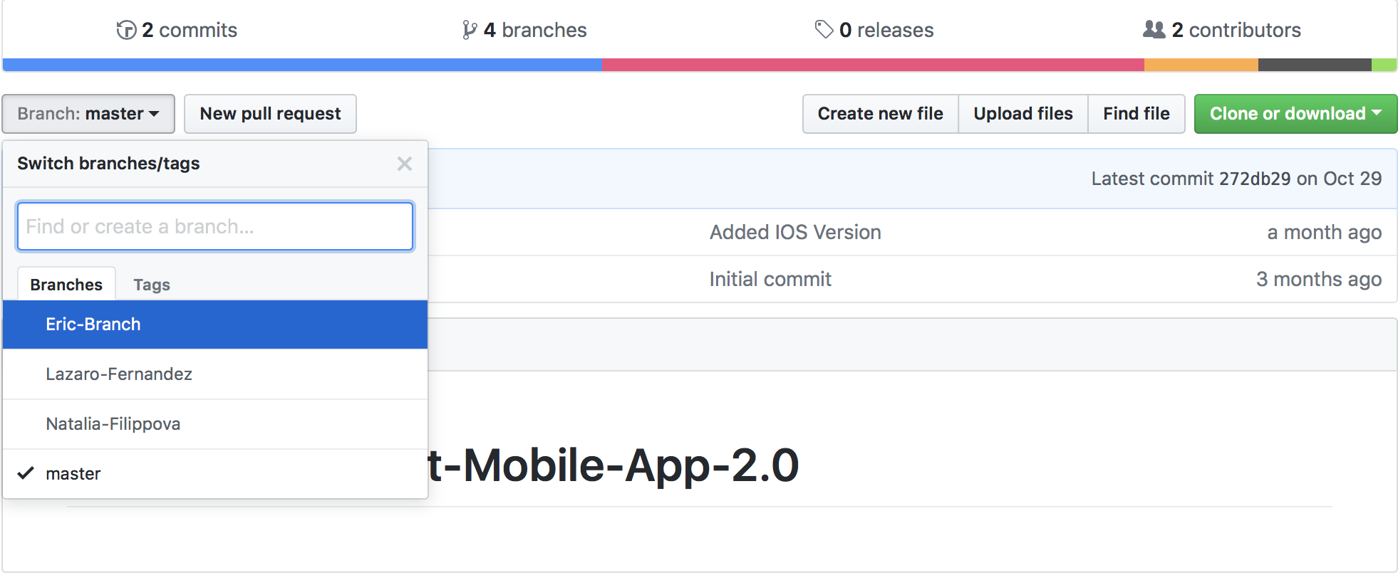

After that, click on the green button ‘Clone or download’ located at the top right hand corner and select ‘Open in Desktop’.

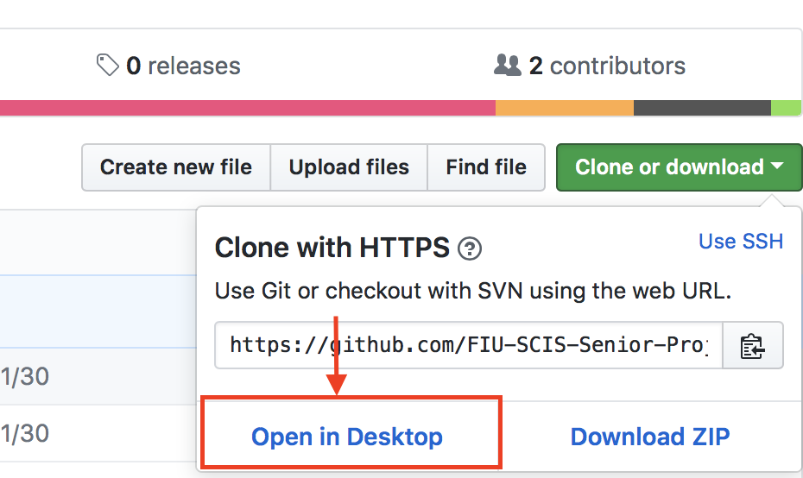

Then, this screen should display. Choose the location Github will clone the project to and click on ‘Clone’ as follows:

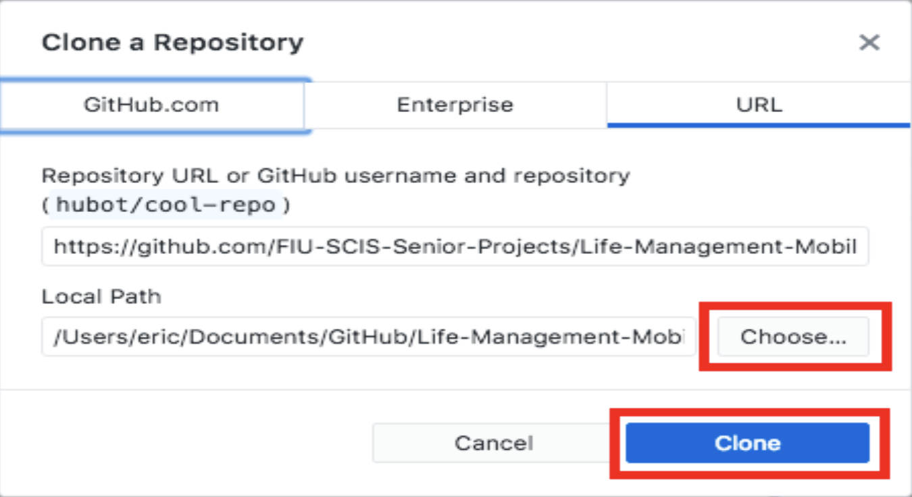

Go to ‘master’ branch and select new Branch. Name it as follows (firstname-lastname)

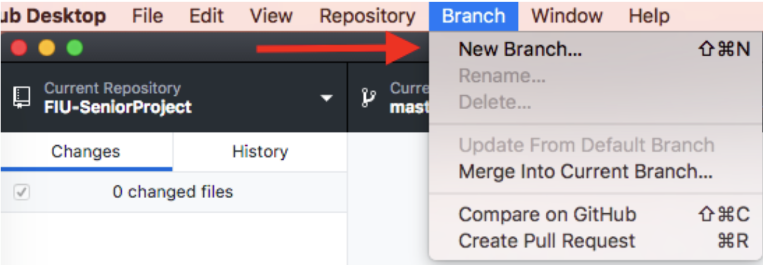

If you want to upload your changes, click on ‘Merge into Current Branch’. Make sure you are in your branch for this. Then click on ‘Fetch Origin’ so that it can process your updates and you should see it in Github.

**2.**  Youtube Android Player API

Go to Google Developers’ Console page in console.developers.google.com. If you are not logged-in, please do so using your google account. When you are logged-in, click on the top arrow to create a new project.

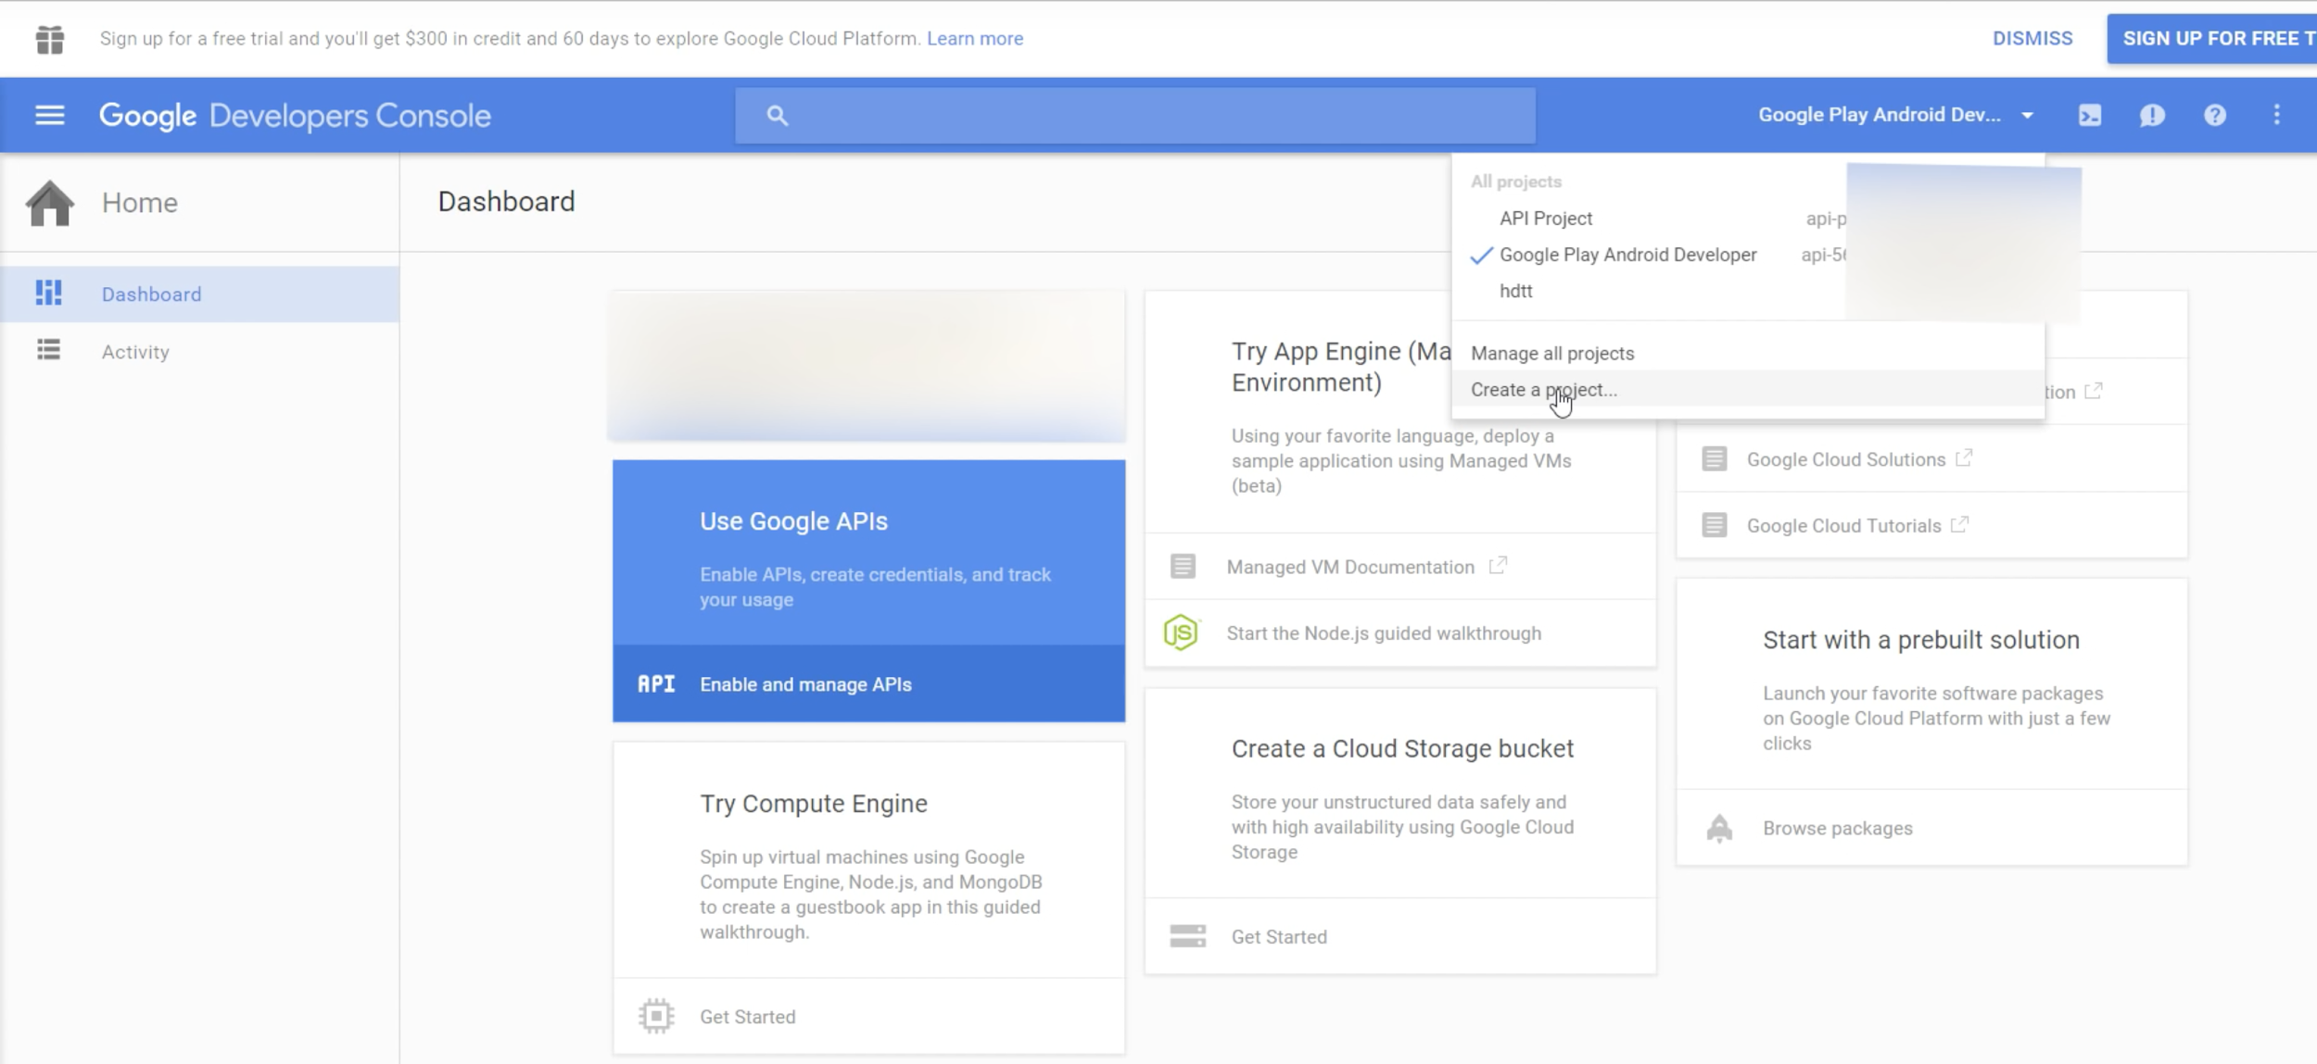

Call it any name and continue

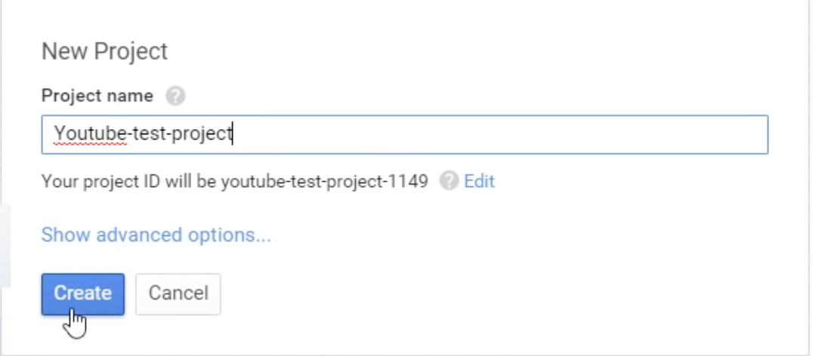

Then on the navigation menu on the left, choose API Manager and select ‘Youtube Data API’.

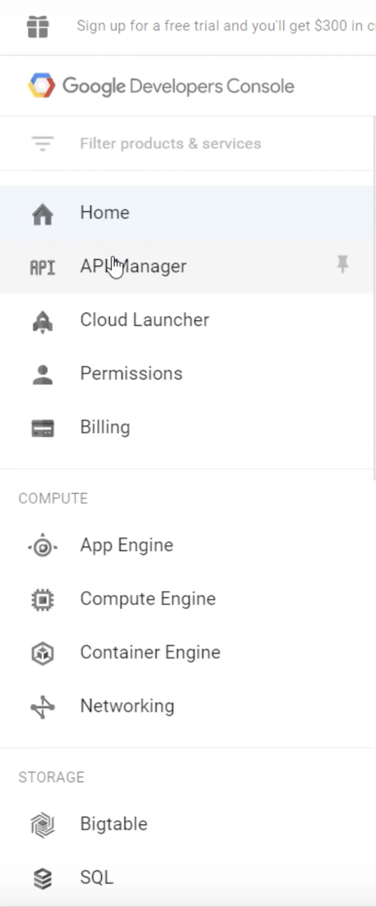

Then click on enable API and click on ‘Go to Credentials’. Click on Add Credentials, you should see a window similar to this:

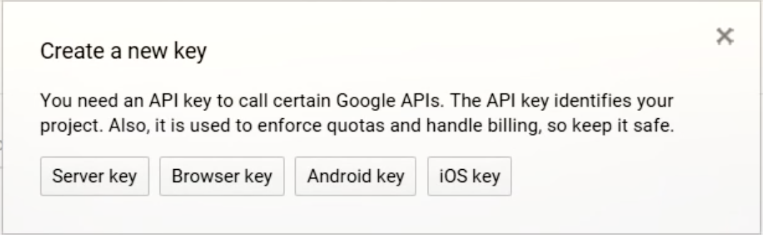

Select Android key and type the following command starting with keytool.. in Android Studio and follow the steps.

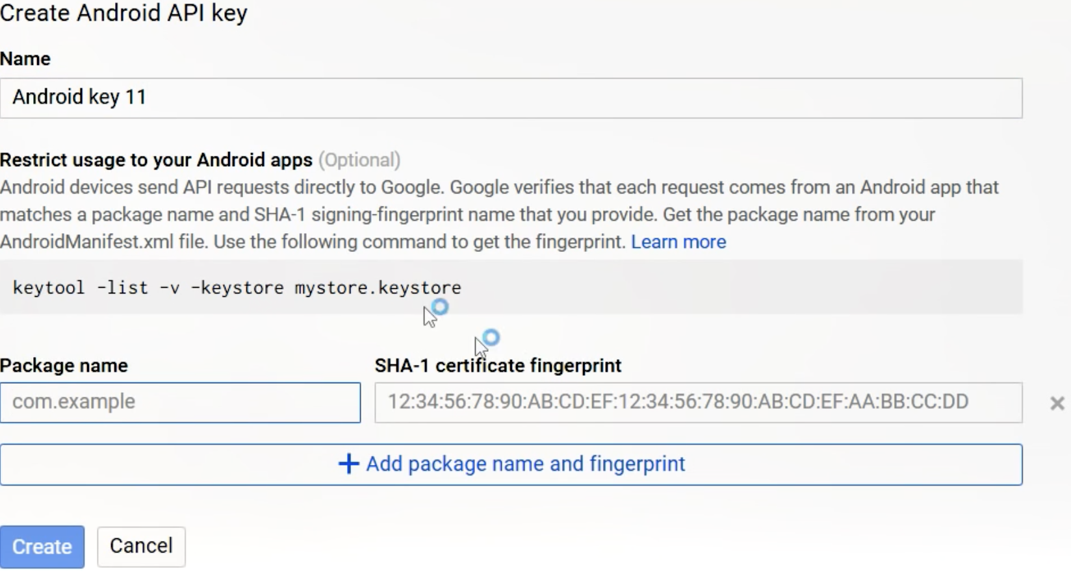

After completing step above, you should see your SHA certificate fingerprint, paste it in the above page along with the package name of your Android Project and click on Create button. You should see a message similar to this.

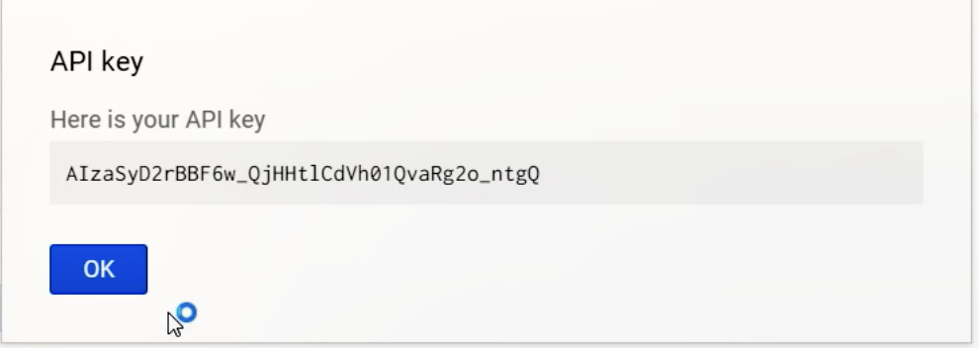

Go to Youtube Player API located at developers.google.com/youtube/android/player/downloads and click on Download

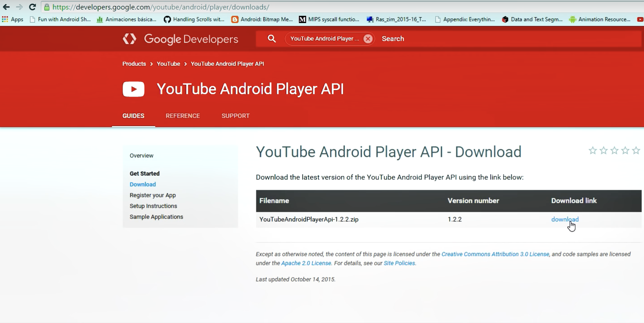

Unzip the file, and open the ‘libs’ folder. You should see a file named ‘YoutubeAndroidPlayerApi.jar’, copy that file and paste it your Android Studio libs folder.

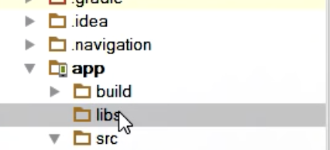

Then go to File->Project Structure. In the pop up, navigate to ‘Dependencies’ and click on Add as follows:

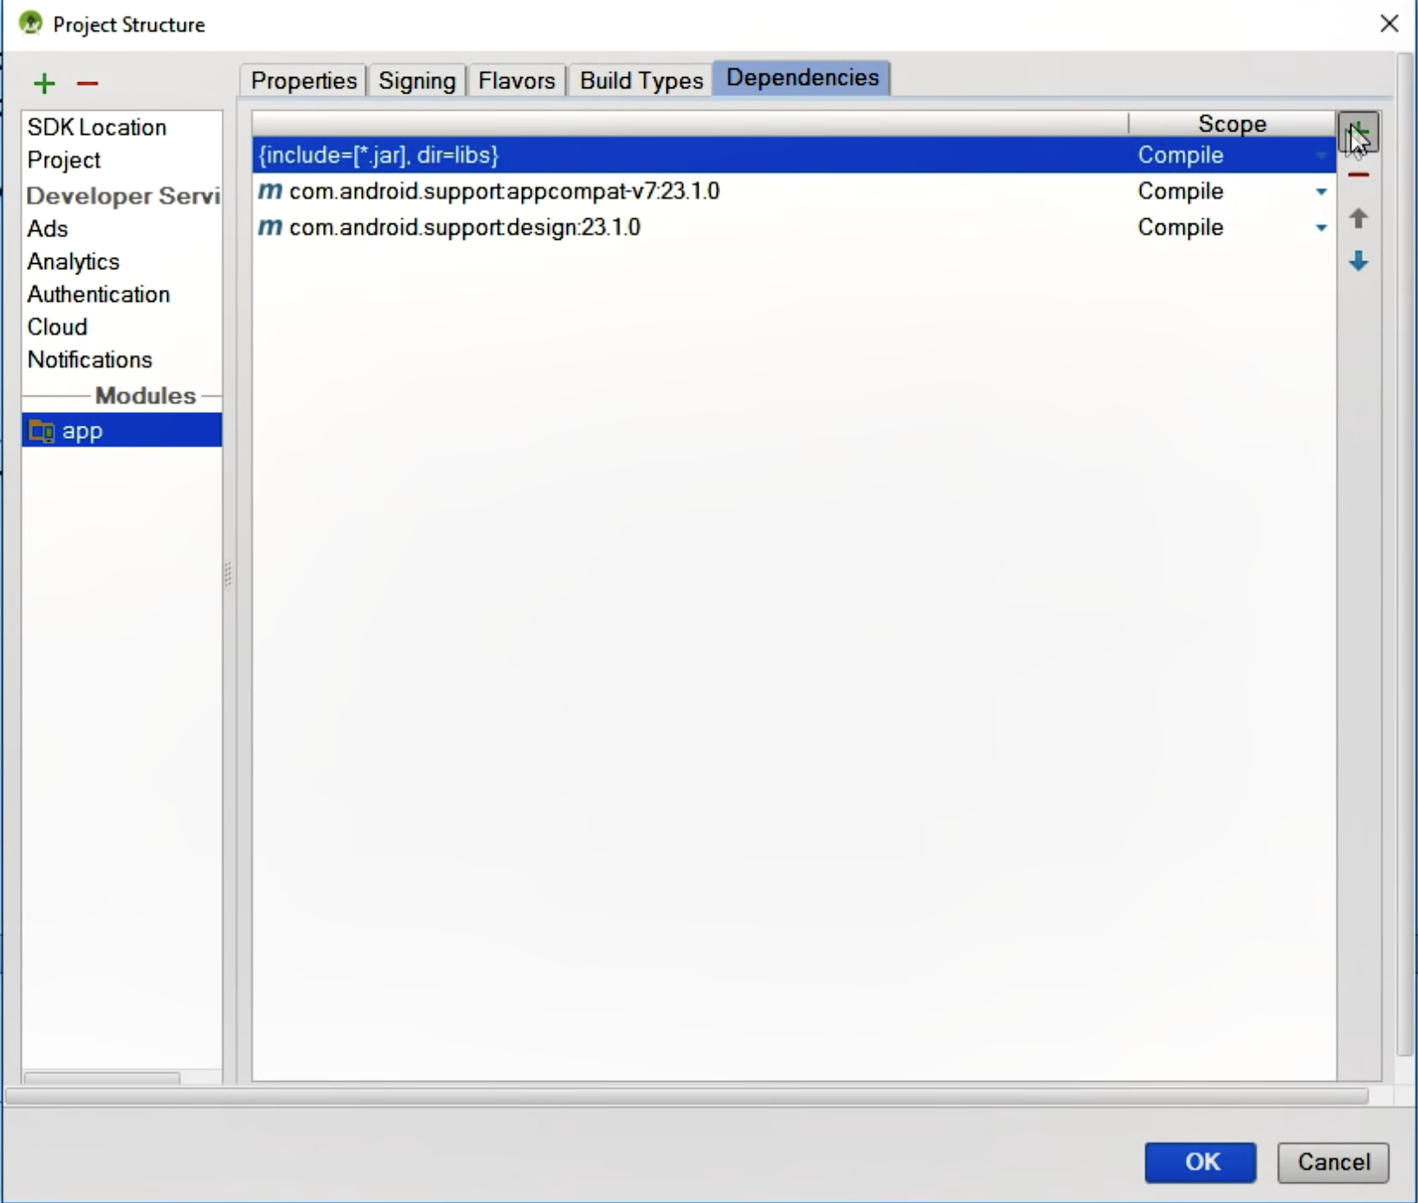

Then click on ‘File Dependency’ and select the downloaded jar file and hit OK. After completing this, you should be able to play any youtube video in your Android Studio project.

**3.** For the **project installation**, the following is required to be installed before continuing:

* Java Development Kit (you can download it from here

<http://www.oracle.com/technetwork/java/javase/downloads/jdk8-downloads-2133151.html> )

* Android Studio 2.3.3 or later version, Android SDK tools and SDK manager

(you can download all it from here

<https://developer.android.com/studio/index.html?gclid=Cj0KEQiAm-CyBRDx65nBhcmVtbIBEiQA7zm8lWCaBd9n9KYYunFXxXsQCPojBVHk5eIH4p9CWM1eLfUaAmd28P8HAQ>)

* Android Emulator – Nexus 5X API 26 virtual device, which was used to test the app (build it by navigating to **Tools > Android > AVD Manager**). 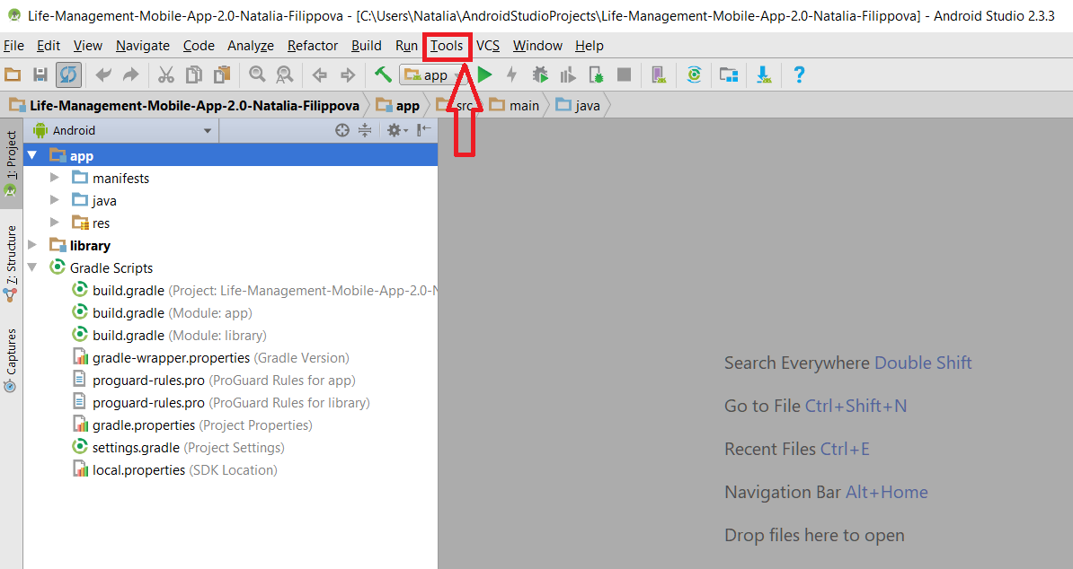

After virtual device has been created, you will be able to see it in Android Virtual Device Manager window.

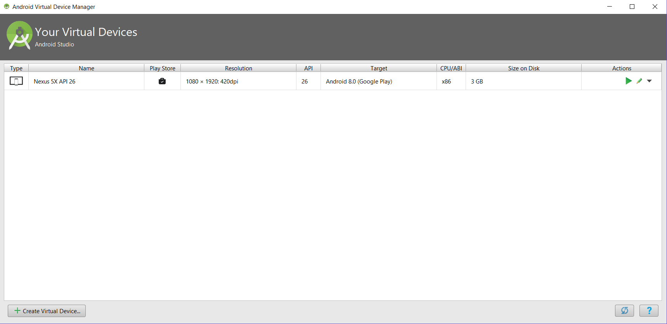

Go to this link <https://github.com/FIU-SCIS-Senior-Projects/Life-Management-Mobile-App-2.0>

And download the project from ‘Lazaro-Fernandez’ or ‘Natalia-Filippova’ branch.

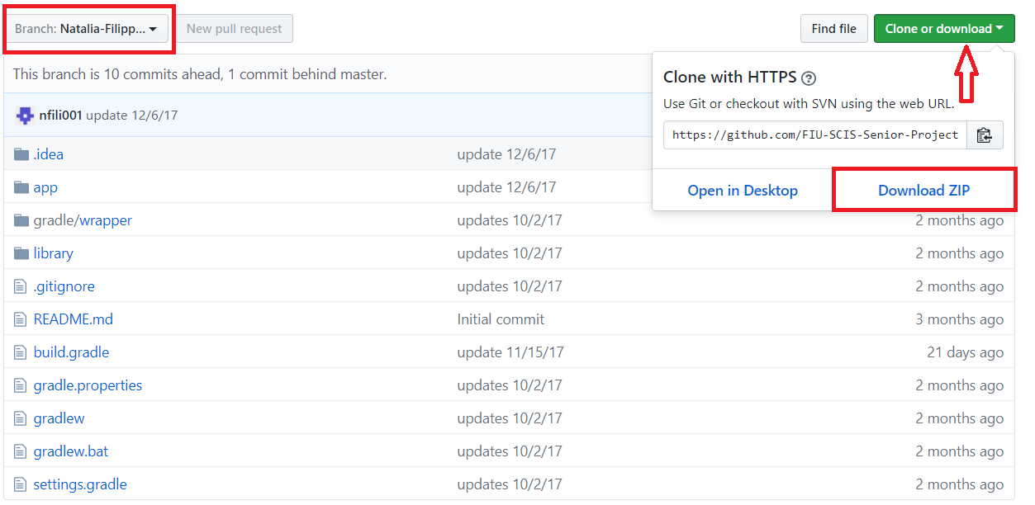

Find the location where you have downloaded and unzipped Life Management Mobile App 2.0 project and copy the whole folder for the project. Go to your **AndroidStudioProjects** folder location and paste the copied project’s folder there:

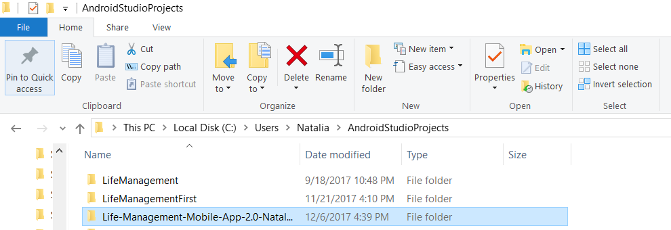

This should be the content of the Life-Management-Mobile-App-2.0 folder:

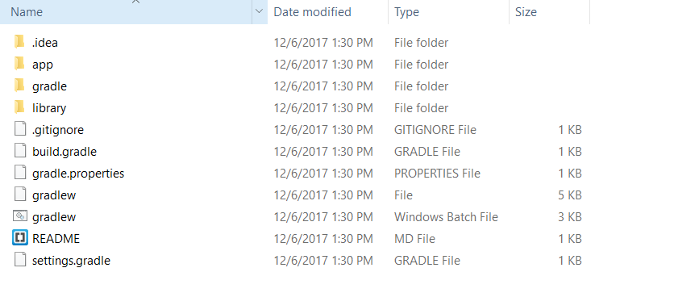

Launch Android Studio and close any open Android Studio projects. From the Welcome screen click **Open an existing Android Studio project**, find the project’s folder, select it and click OK button.

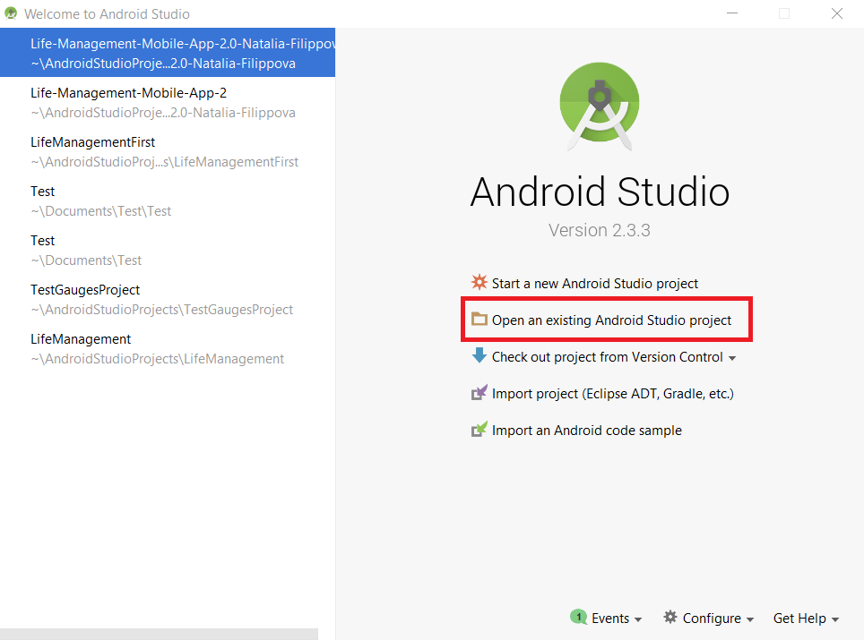

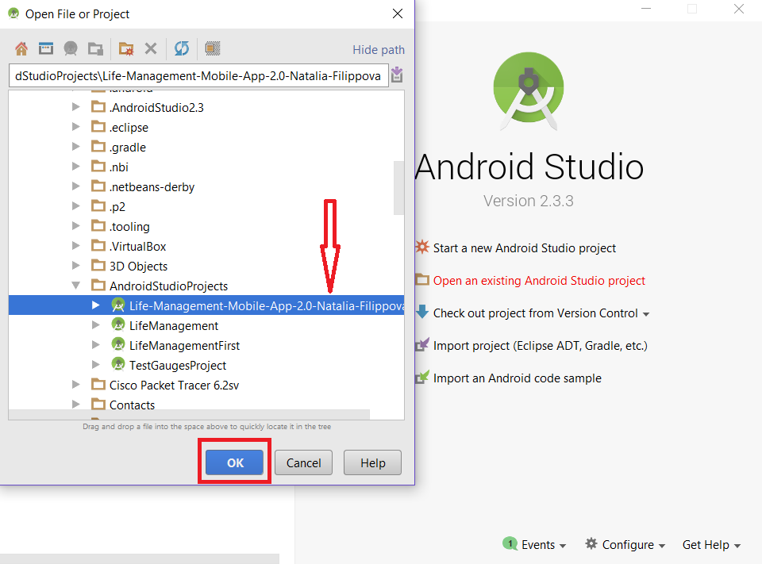

Once the project is opened in the Android Studio, you can click on the **Project** tab to see the project’s structure.

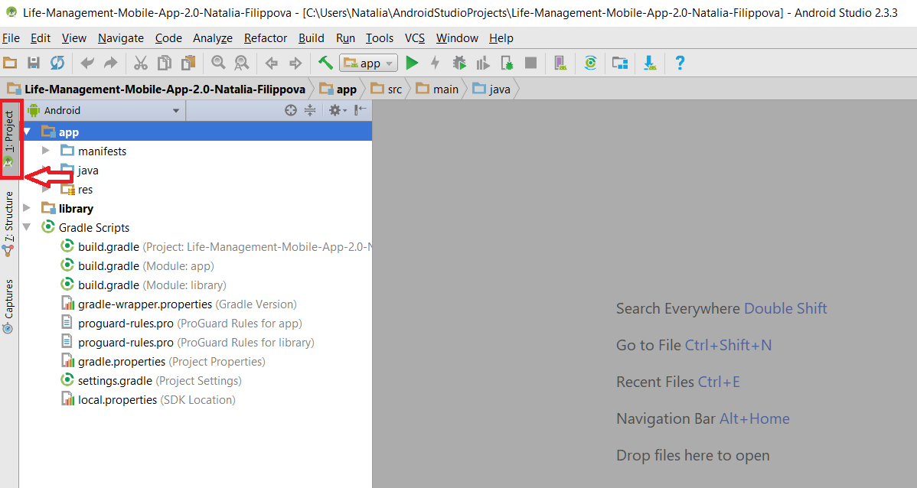

Before continuing, check if the installed versions of your SDK platforms and tools match these by opening the SDK Manager (click the **Android SDK Manager** button in Android Studio welcome screen or **Tools > Android > SDK Manager**). Install the tools that are missing (those that are checked have to be installed).



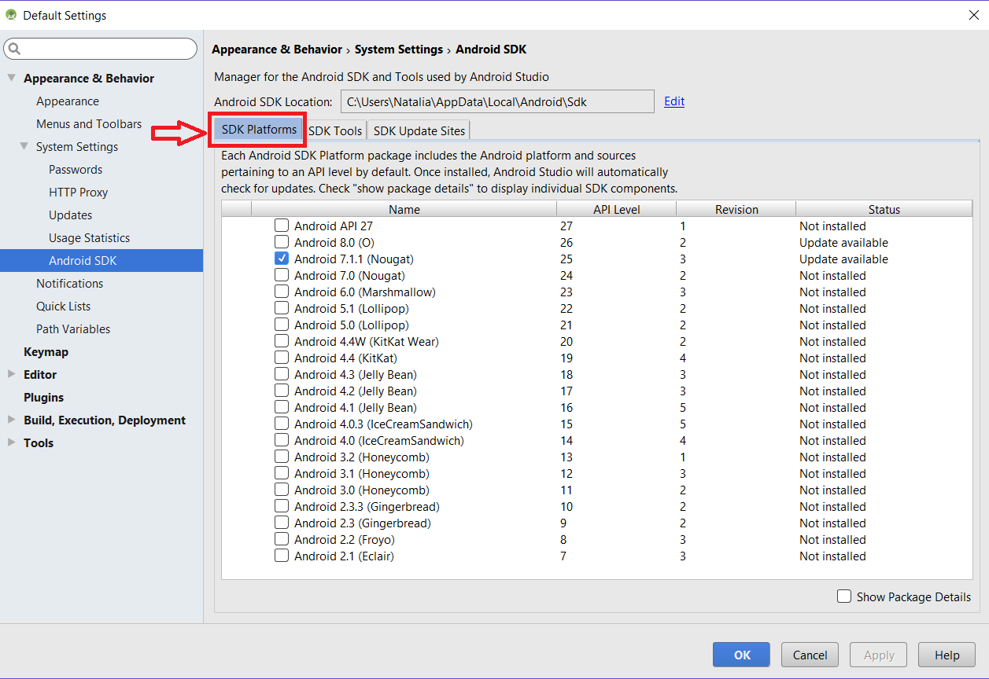

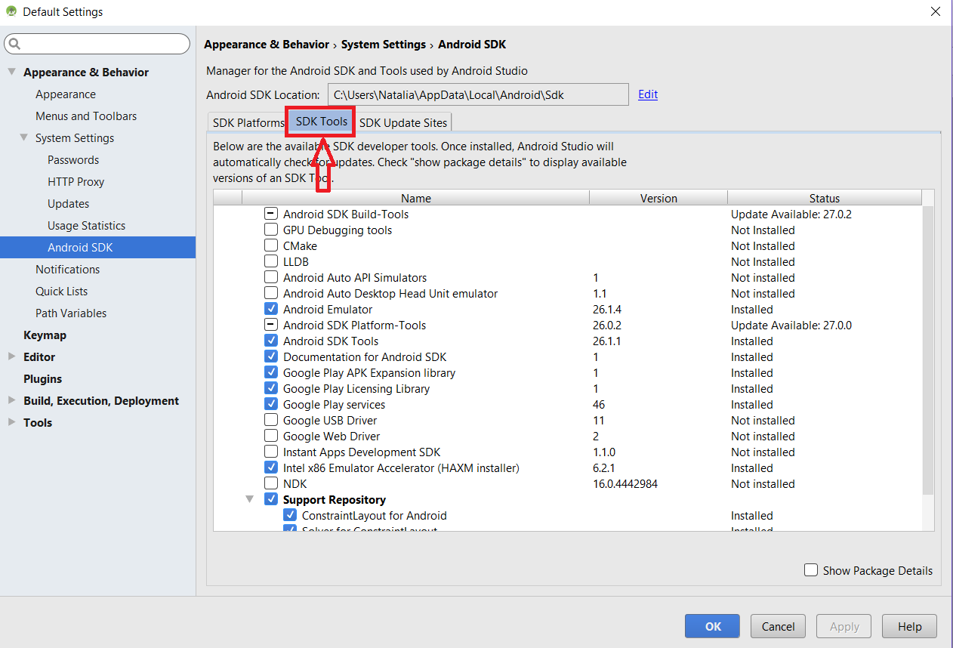

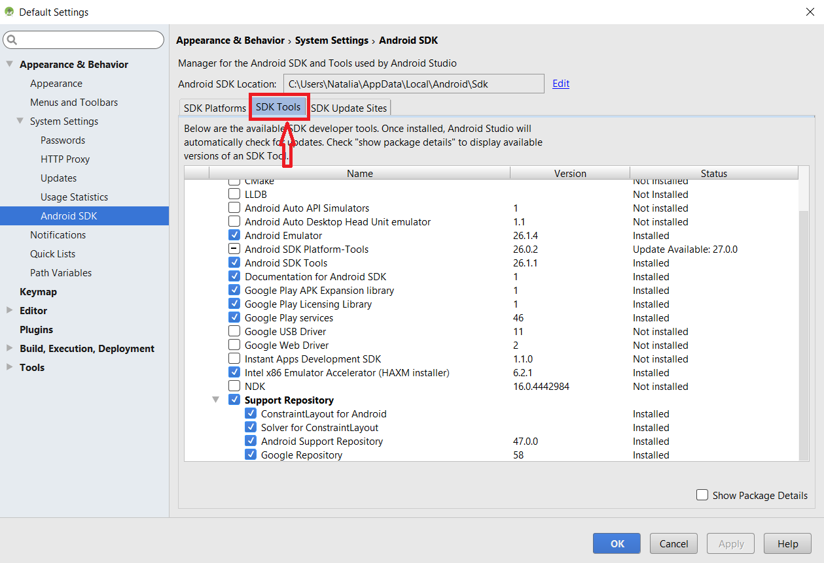

We are using cloud-hosted Firebase database which is located at this link

<https://console.firebase.google.com/project/life-management-f0cdf/database/life-management-f0cdf/data> . If you are not logged-in, please do so using your FIU email account.

Make sure that the project is connected to Firebase database. You can do so by using Firebase Assistant in Android Studio. Click **Tools > Firebase** to open the **Assistant** window.



Click to expand one of the listed features (for example, Analytics), then click the provided tutorial link (for example, Log an Analytics event).

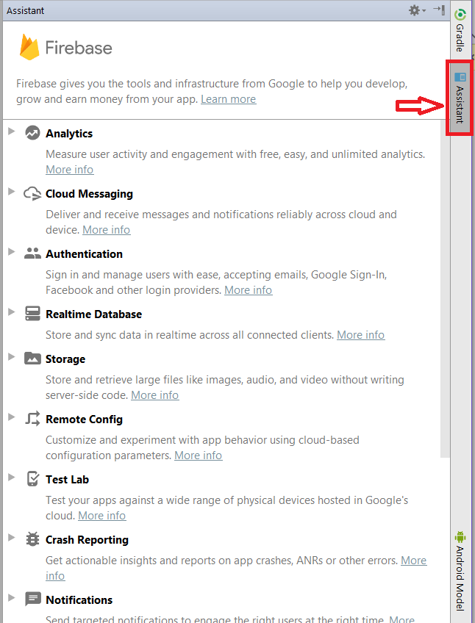

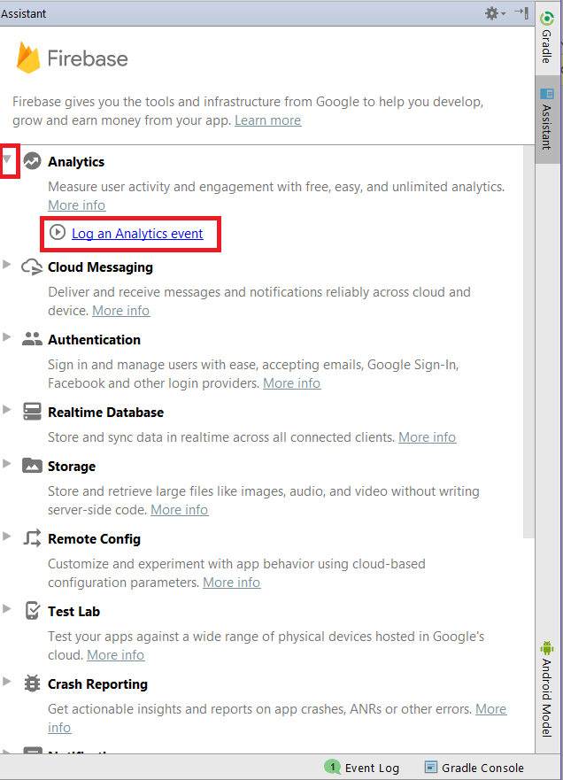

Click **Connect to Firebase** button to connect to Firebase.

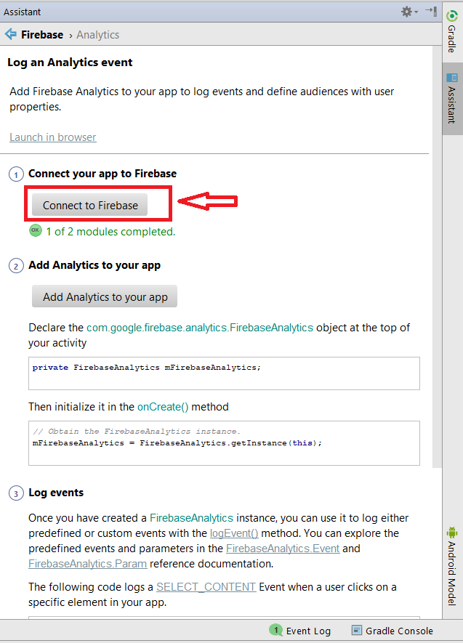

Make sure everything works properly by building and running the project. To build it use the **Build** menu option and click **Make Project**. If the project is not building properly you should resolve the issues before continuing.

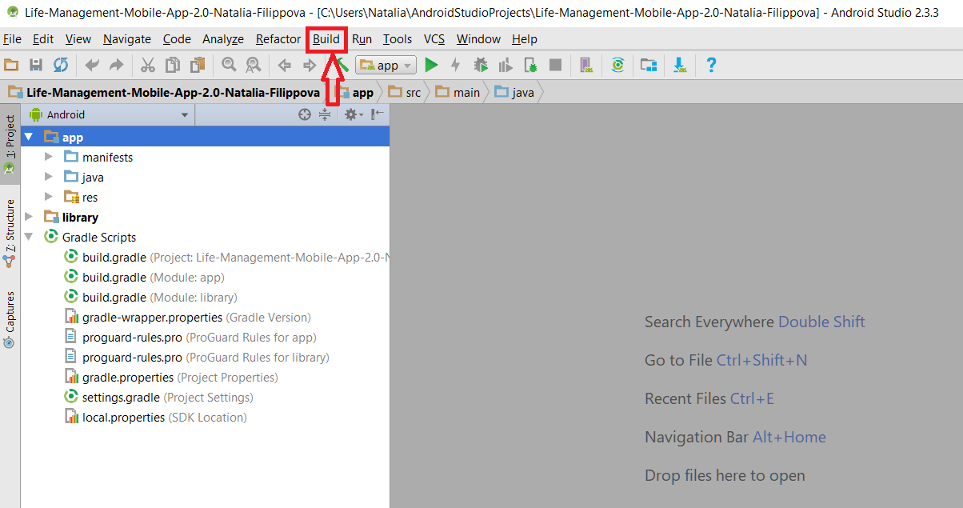

To run the project use the **Run** menu option and click **Run ‘app’**.

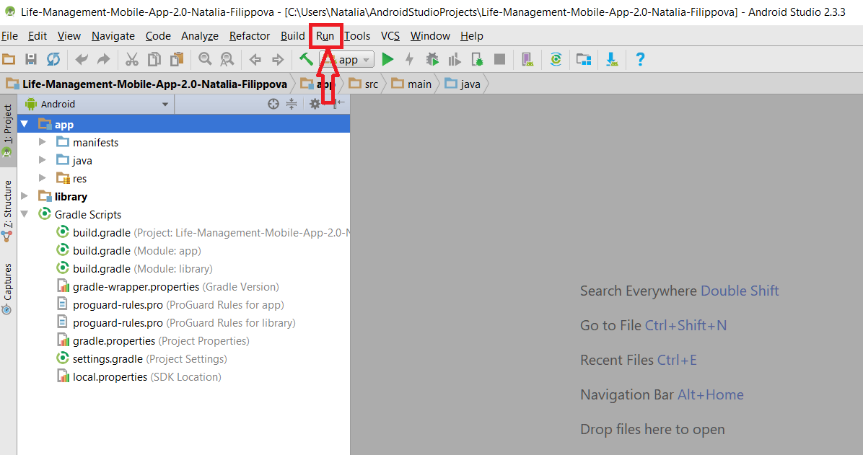

In the window select Nexus 5X API 26 virtual device (it has to be preinstalled) and click OK.

